Flask API Activity

Question 1
!python api.py
This started the Flask development server on http://127.0.0.1:5000 in debug mode.
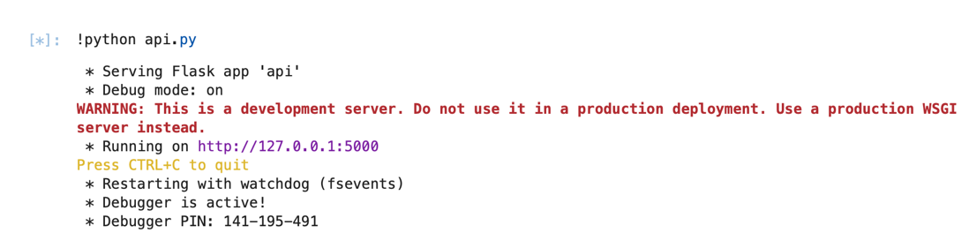

Question 2
w3m http://127.0.0.1:5000/user/Ann
What happens:
The API returns Ann’s details in JSON format.
Why:
The GET method searches the users list and finds a match for "Ann", so it returns the user data with a 200 (success) status code.
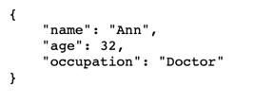
Question 3
w3m http://127.0.0.1:5000/user/Adam
What happens:
The API returns:
"User not found"
Why:
There is no user named “Adam” in the dataset. The GET method fails to find a match and returns a 404 (not found) response.


Question 4
Flask enables the creation of web applications and REST APIs in Python.
In this task, it allows:
- Defining URL endpoints (/user/<name>)
- Handling HTTP requests (GET, POST, PUT, DELETE)
- Returning structured responses (JSON)
This means a standard Python script can function as a web-based service.

Architecture Evolution Activity
Following the emergence of microservices, software architecture has evolved into what is now commonly known as cloud-native architecture. While microservices focus on decomposing applications into smaller, independent services, modern systems extend this approach by incorporating technologies that support scalability, resilience, and automation at scale.
A key development has been the adoption of containerisation, where applications are packaged with their dependencies using tools such as Docker. Containers enable consistent deployment across environments and form the foundation for modern distributed systems.
To manage large numbers of microservices, container orchestration platforms such as Kubernetes have become standard. These platforms automate deployment, scaling, networking, and fault tolerance, addressing operational challenges that early microservice architectures faced.
Another important evolution is the introduction of service meshes (e.g., Istio), which handle service-to-service communication, security, and observability without embedding this logic directly into application code. This improves maintainability and standardisation across distributed systems.
In addition, serverless computing and event-driven architectures have gained prominence. These approaches allow developers to focus on writing functions that respond to events, while infrastructure management is handled by cloud providers. These further abstracts system complexity and improves scalability.
Modern architectures also emphasise observability, using tools such as Prometheus and Grafana to monitor system behaviour, detect failures, and ensure reliability.
Overall, the evolution beyond microservices reflects a shift from simply decomposing applications to managing complex distributed systems efficiently. Contemporary architectures combine microservices with containers, orchestration, serverless computing, and observability tools to deliver scalable, resilient, and maintainable software systems.

